DIGITAL EGYPT PIONEERS INITIATIVE (DEPI)
React Frontend Development Track

GRADUATION PROJECT DOCUMENTATION

Car Performance & Tuning Lab
Configure, Modify, and Simulate Performance Upgrades Instantly
Prepared by
Jomana Ahmed
Shady Kerollos
Submission Date: July 2026

1. Executive Summary
The “Car Performance & Tuning Lab” is a web-based simulation platform developed as a graduation project for the Digital Egypt Pioneers Initiative (DEPI) React Frontend Development Track. The application allows automotive enthusiasts, students, and hobbyists to configure a vehicle's technical specifications, apply a range of realistic performance modifications, and instantly visualize the resulting impact on horsepower, torque, acceleration, top speed, and fuel consumption.
The platform combines a modern, responsive React and TypeScript front end with a Node.js and Express back end that hosts the calculation engine responsible for translating modification choices into quantifiable performance outcomes. Results are presented through an interactive dashboard featuring bar charts and radar charts, a build-saving and comparison workspace, bilingual (Arabic/English) support, a dark-themed interface, and the ability to export a complete performance report as a PDF document.
This documentation presents the full lifecycle of the project, including its objectives, scope, system architecture, technology stack, calculation methodology, user interface walkthrough, testing approach, challenges encountered during development, and recommendations for future enhancement. It is intended to serve as the formal record of the project for academic evaluation and as a reference for any future development team extending the system.

2. Project Overview

2.1 Background
Automotive tuning and performance modification is a widely practiced hobby and profession across the world, yet the tools available to estimate the effect of modifications before committing money and time to a physical build are often fragmented, overly technical, or locked inside proprietary workshop software that is inaccessible to everyday enthusiasts. Most online calculators only address a single metric, such as horsepower gain from a single part, and rarely offer a unified, visual, and interactive way to explore how multiple modifications interact with one another.
As part of the DEPI React Frontend Development Track, the team was required to design and build a complete, production-quality single-page application that demonstrates mastery of component-based architecture, state management, API integration, data visualization, and responsive design. The automotive tuning domain was selected because it provides a rich set of numerical relationships, a visually engaging subject matter, and clear opportunities to demonstrate both front-end and back-end integration skills.

2.2 Problem Statement
Car enthusiasts frequently want to answer questions such as: “If I install a turbocharger and a cold air intake on my car, how much horsepower and torque will I gain, and how will that affect my 0-100 km/h time, top speed, and fuel economy?” Answering this question currently requires either specialized dynamometer testing, scattered forum knowledge, or manual calculation using rule-of-thumb percentages. There is no single, easy-to-use, visually intuitive web application that lets a user select a vehicle, apply modifications, and immediately see a clear, quantified, and comparative breakdown of the expected performance changes.

2.3 Proposed Solution
The Car Performance & Tuning Lab addresses this gap by providing an interactive simulator in which a user enters or selects a vehicle's baseline specifications, chooses from a curated catalogue of performance modifications (such as turbochargers, cold air intakes, exhaust systems, and suspension upgrades), and receives real-time, calculated results for horsepower, torque, acceleration, top speed, and fuel consumption. The application visualizes these results through dashboards, comparison charts, and a radar-style performance profile, while also allowing users to save multiple builds, compare them side by side, and export a professional PDF report summarizing the analysis.

3. Project Objectives
The project was guided by the following core objectives:
- Deliver an accurate simulation engine: implement a calculation engine that realistically models the relationship between vehicle modifications and key performance indicators.
- Provide an intuitive user experience: design a clean, dark-themed, responsive interface that allows users of any technical background to configure a vehicle and understand the results at a glance.
- Demonstrate full-stack integration: connect a React/TypeScript front end to a Node.js/Express back end through a well-structured REST API, reinforcing the skills taught throughout the DEPI track.
- Enable data-driven comparison: allow users to save multiple vehicle builds and compare them against one another using tables and charts.
- Support accessibility and localization: provide full Arabic and English language support to serve a wider audience.
- Provide exportable documentation: allow users to generate and download a formatted PDF report summarizing their simulation results.
- Apply modern software engineering practices: use component-based design, type safety with TypeScript, and clean state management throughout the codebase.

4. Scope of the Project
The scope of the Car Performance & Tuning Lab covers the design, development, and testing of a functioning web-based simulation tool. It is intentionally scoped as an educational and illustrative simulator rather than an engineering-grade vehicle dynamics tool, and therefore does not attempt to replace certified automotive engineering software.

In Scope
- User authentication (registration and login) to allow personalized sessions.
- A configuration panel for entering vehicle weight, horsepower, torque, and drivetrain type, or selecting from predefined vehicle presets.
- A catalogue of selectable performance modifications, each affecting horsepower, torque, and fuel consumption by a defined percentage.
- A real-time calculation engine that recomputes acceleration, top speed, and fuel consumption whenever inputs change.
- A results dashboard with numerical cards, a performance score, and a vehicle preview panel.
- Interactive bar and radar charts comparing stock and modified performance values.
- A build-saving feature and an advanced comparison workspace for evaluating two or more saved builds.
- PDF export of the full performance analysis.
- Arabic/English bilingual interface support and a dark-mode visual theme.

Out of Scope
- Real-world telemetry, OBD-II integration, or connection to physical vehicle hardware.
- Certified engineering-grade physics simulation (e.g., full computational fluid dynamics or drivetrain torque modeling).
- Payment processing or e-commerce functionality for purchasing real modification parts.
- Native mobile applications (the project is delivered as a responsive web application).

5. System Features

5.1 Core Features
- Vehicle Configuration Panel: a dedicated panel where users enter vehicle weight, horsepower, torque, and select drivetrain type (FWD, RWD, or AWD), or choose from a list of predefined car presets for quick configuration.
- Real-Time Calculations: as soon as a user changes an input value or toggles a modification, the application recalculates all dependent performance metrics without requiring a page reload or manual submission.
- Performance Dashboard: a results dashboard summarizing horsepower, torque, 0-100 km/h acceleration, top speed, fuel consumption, and an overall performance score, each displayed on its own card with stock-value context.
- Performance Comparison: side-by-side comparison of stock (original) values versus modified values for every metric, with percentage and absolute differences clearly highlighted.
- Interactive Charts: bar charts comparing horsepower and torque, and a radar (spider) chart summarizing the overall performance profile across five dimensions: horsepower, torque, acceleration, top speed, and fuel consumption.
- Save Builds: users can name and save their current configuration as a build, preserving all specifications and applied modifications for later reference.
- Compare Builds: an advanced comparison workspace allows two saved builds to be selected and compared directly, including a detailed metrics table with computed differences and a grouped bar chart.
- PDF Export: a one-click export function generates a polished PDF report containing technical specifications, applied modifications, and a full table of performance results and differences.
- Arabic/English Support: a language toggle in the header allows the entire interface to switch between English and Arabic, supporting a bilingual user base.
- Dark Mode: the interface is built around a dark visual theme with orange and cyan accent colors, improving readability and reducing eye strain during extended use.

5.2 Advanced Features
- User Authentication (Login/Register): a secure login and registration flow allows each user to maintain a personalized session and access their saved builds.
- Vehicle Presets Database: a curated set of predefined vehicles (for example, popular Toyota and BMW models) with realistic stock specifications that can be loaded instantly instead of manual entry.
- Vehicle Image Preview: a visual preview area that displays a representative image or blueprint placeholder for the selected vehicle preset.
- Performance Score System: a composite 0-100 score that classifies the vehicle's overall performance tier (e.g., Street, Sport, Track) based on its combined metrics.
- Cost Estimator: an estimated cost breakdown associated with the selected modifications, giving users a sense of the investment required to achieve the simulated gains.
- Recommended Build Assistant: a guided suggestion feature that recommends a combination of modifications based on the user's performance goals.
- Simulation History: a history log of previous simulation sessions, enabling users to revisit and reload earlier configurations.

6. System Architecture
The Car Performance & Tuning Lab follows a client-server architecture that cleanly separates presentation, business logic, and data persistence concerns. The diagram below (described textually) illustrates the flow: the React/TypeScript client renders the user interface and manages local UI state; it communicates with a Node.js/Express back end over a RESTful API; the back end hosts the calculation engine that performs the performance modeling; and the browser's local storage persists user preferences and saved builds for quick access without repeated server round-trips.

6.1 Frontend (React + TypeScript)
The front end is built using React with TypeScript to provide strong type safety across components, props, and state. The application is structured into reusable, self-contained components such as the Vehicle Specifications panel, Results Dashboard, Chart components, Build Comparison Workspace, and Authentication forms. TypeScript interfaces define the shape of vehicle data, modification objects, and calculation results, reducing runtime errors and improving maintainability. React state and context are used to manage the currently active configuration, applied modifications, language setting, and authenticated user session across the component tree.

6.2 Backend (Node.js + Express)
The back end is implemented with Node.js and the Express framework, exposing a set of REST endpoints responsible for user authentication, retrieval of vehicle presets, and execution of the performance calculation logic. Express middleware handles request validation, JSON parsing, and error handling, ensuring that malformed requests are rejected gracefully with informative error messages rather than causing the application to crash.

6.3 API Communication
Communication between the front end and back end is performed using Axios, which issues asynchronous HTTP requests to the Express API. Endpoints follow REST conventions, for example, POST requests to submit a vehicle configuration for calculation, GET requests to retrieve vehicle presets, and POST/GET requests to manage authentication sessions. Responses are returned in JSON format and mapped directly onto the TypeScript interfaces used throughout the front end, ensuring consistency between what the server computes and what the client renders.

6.4 Calculation Engine
The calculation engine is the core business logic layer of the application. It receives the vehicle's baseline specifications and the list of selected modifications, applies the percentage-based adjustments associated with each modification to horsepower, torque, and fuel consumption, and then derives the secondary performance metrics of 0-100 km/h acceleration and top speed using physics-informed formulas described in detail in Section 11. The engine is designed as a pure, stateless function so that identical inputs always produce identical, reproducible outputs, which simplifies both testing and validation.

6.5 Local Storage
The browser's Local Storage API is used to persist lightweight, non-sensitive data such as the user's language preference, the list of saved builds, and cached simulation history. This reduces the number of network requests required for routine interactions and allows saved builds to remain available even if the user temporarily loses connectivity to the back end.

7. Technology Stack
The following table summarizes the primary technologies used to build the Car Performance & Tuning Lab, along with the role each technology plays in the system.
Technology | Category | Role in the Project
React.js | Frontend Library | Builds the component-based, single-page user interface.
TypeScript | Language | Adds static typing to the front-end code, reducing bugs and improving maintainability.
Node.js | Backend Runtime | Executes the server-side JavaScript environment for the API and calculation engine.
Express.js | Backend Framework | Handles routing, middleware, and REST API endpoint definitions.
Axios | HTTP Client | Manages asynchronous communication between the React front end and the Express API.
Recharts | Data Visualization | Renders the bar charts used for horsepower and torque comparisons.
Chart.js | Data Visualization | Renders the radar chart used for the overall performance profile.
jsPDF | Document Generation | Generates the downloadable PDF performance report.
Local Storage (Web API) | Client-Side Persistence | Stores language preference, saved builds, and simulation history in the browser.

8. System Workflow
The following sequence describes how data flows through the system, from the moment a user interacts with the interface to the moment updated results are displayed:
- 1. User Input: the user selects a vehicle preset or manually enters weight, horsepower, torque, and drivetrain type in the Vehicle Configuration Panel, and optionally checks one or more performance modifications.
- 2. State Update: each input change updates the corresponding React state, immediately reflecting the new values in the interface.
- 3. Request Dispatch: the updated configuration object is sent via Axios to the Express back end's calculation endpoint.
- 4. Server-Side Calculation: the calculation engine on the server applies the modification percentages to the base specifications and computes the derived metrics (acceleration, top speed, fuel consumption, and performance score).
- 5. Response Handling: the calculated results are returned as a JSON payload and received by the front end via Axios.
- 6. UI Re-render: React updates the Results Dashboard, comparison cards, and charts to reflect the newly calculated values, with visual indicators (color-coded deltas) showing the change relative to the stock configuration.
- 7. Persistence (Optional): if the user chooses to save the build, the configuration and results are stored both in the browser's Local Storage and, where applicable, associated with the user's account for later retrieval.
- 8. Export (Optional): if the user requests a PDF export, jsPDF assembles the current specifications, modifications, and results into a formatted document that is downloaded to the user's device.

9. Calculation Engine
The calculation engine translates the percentage-based effects of each modification into concrete performance figures. Each modification in the catalogue (such as a Turbo Charger or Cold Air Intake) defines its own percentage impact on horsepower, torque, and fuel consumption. These percentages are additive across all selected modifications and are applied to the vehicle's stock horsepower, torque, and fuel consumption values to produce the modified values shown throughout the dashboard.

9.1 Horsepower and Torque
Modified horsepower and torque are calculated by applying the sum of the percentage bonuses from all active modifications to the stock values. For example, a Turbo Charger modification that adds +35% horsepower and +30% torque will increase a 382 HP / 500 Nm stock configuration to approximately 515.7 HP and 650 Nm, as reflected in the application's exported reports.

9.2 Acceleration (0-100 km/h)
Acceleration time is modeled as a function of the vehicle's power-to-weight ratio. As horsepower increases and/or vehicle weight decreases, the power-to-weight ratio improves, which the engine translates into a proportionally shorter 0-100 km/h time. The engine also accounts for drivetrain type, since all-wheel-drive configurations typically translate power to the road more efficiently under acceleration than front-wheel-drive configurations, resulting in a small adjustment factor applied to the base acceleration estimate.

9.3 Top Speed
Top speed is estimated from the balance between available horsepower and the vehicle's aerodynamic and rolling resistance, approximated in the model through a simplified relationship between power output and weight. As horsepower increases relative to the vehicle's mass, the engine increases the projected top speed, while heavier vehicles or those with unchanged power output see comparatively smaller top-speed gains.

9.4 Fuel Consumption
Fuel consumption (expressed in liters per 100 km) increases as modifications that add horsepower and torque are applied, reflecting the real-world trade-off between performance gains and efficiency. Each modification defines its own fuel consumption penalty (for example, a Turbo Charger adds +12% fuel consumption alongside its power gains), and these penalties are summed and applied to the vehicle's stock fuel consumption value to produce the modified figure.

9.5 Performance Score
The Performance Score is a composite metric on a 0-100 scale that combines normalized values of horsepower, torque, acceleration, and top speed into a single indicator of overall capability. Based on the resulting score, the vehicle is classified into a descriptive performance tier such as Street, Sport, or Track, which is displayed prominently on the Results Dashboard and used throughout the build comparison workspace.

10. User Interface Screens

10.1 Login and Registration Screen
The entry point of the application presents users with a clean, centered authentication card set against the application's signature dark background. The panel includes fields for Username and Password, a prominent orange “Login” call-to-action button, and a link for new users to register an account. The application header also exposes a language toggle (Arabic/English), demonstrating the platform's bilingual support from the very first screen the user encounters.
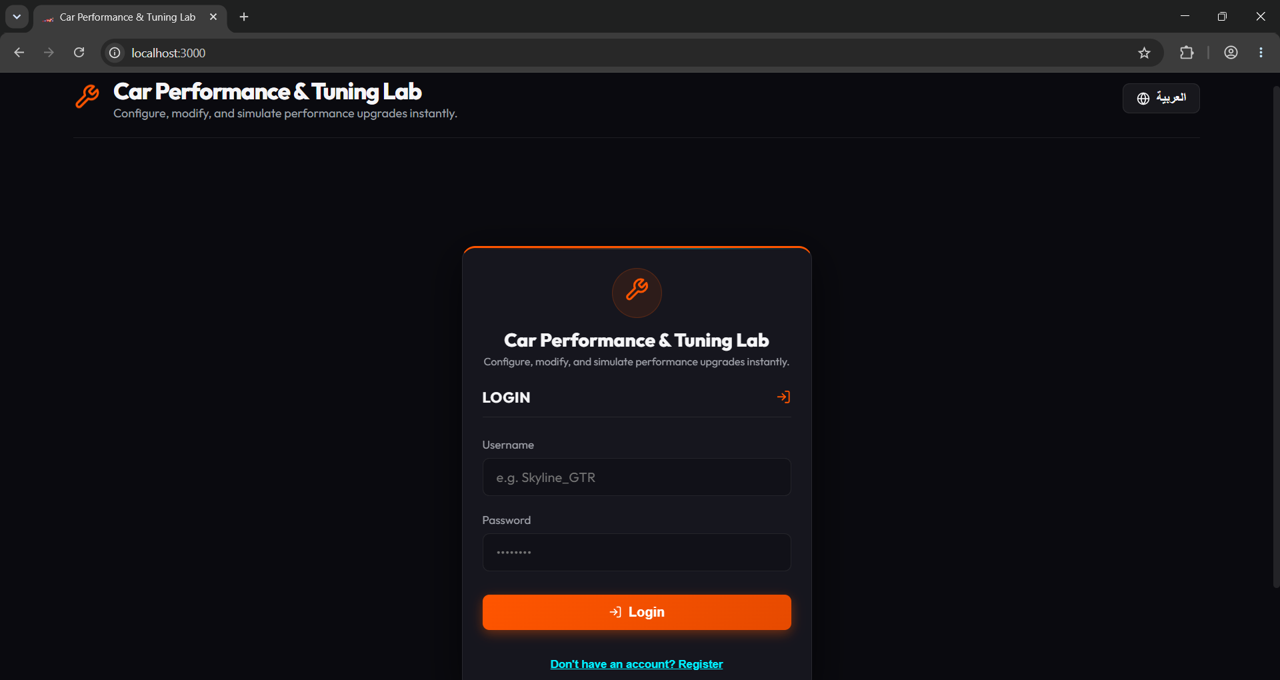
Figure 10.1 — Login screen of the Car Performance & Tuning Lab, showing the authentication card, username and password fields, and the Arabic/English language toggle in the header.

10.2 Vehicle Configuration and Results Dashboard
Once authenticated, the user is welcomed by name and presented with the main workspace, divided into two primary regions. On the left, the Vehicle Specifications panel allows selection of a predefined car preset or manual entry of vehicle weight, horsepower, and torque, along with drivetrain selection (FWD, RWD, or AWD). On the right, the Results Dashboard displays an Active Vehicle Preview panel and a circular Performance Score gauge, followed by individual metric cards for Horsepower, Torque, 0-100 km/h Acceleration, Top Speed, and Fuel Consumption, each showing the current value alongside its corresponding stock value and percentage change.
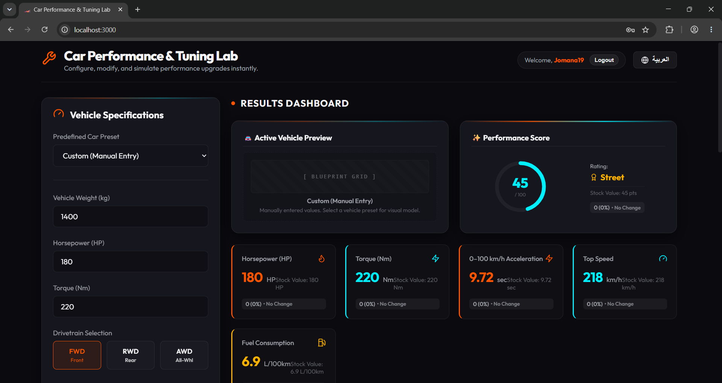
Figure 10.2 — Main dashboard view showing the Vehicle Specifications panel on the left and the real-time Results Dashboard, including the Performance Score gauge and individual metric cards, on the right.

10.3 Interactive Charts and Build Saving
Scrolling further down the dashboard reveals the modification catalogue (illustrated here by the Cold Air Intake option with its associated performance effects), followed by two complementary visualizations: a grouped bar chart comparing Horsepower and Torque between the Stock Value and the Modified Value, and a radar chart summarizing the Overall Performance Profile across five dimensions — Horsepower, Torque, 0-100 km/h Acceleration, Top Speed, and Fuel Consumption. Below the charts, the Save Current Build panel allows the user to name and store their configuration, with a workspace area below it listing all previously saved builds.
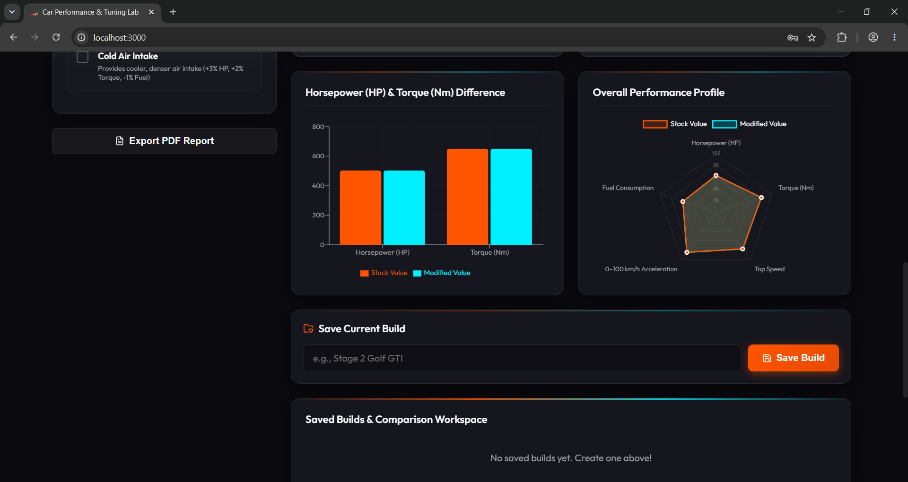
Figure 10.3 — Modification catalogue entry, the Horsepower/Torque bar chart, the Overall Performance Profile radar chart, and the Save Current Build panel with its associated build workspace.

10.4 Advanced Build Comparison Workspace
The Advanced Build Comparison Workspace enables users to select two previously saved builds — in this example, a Toyota-based build and a BMW-based build — from two dropdown selectors, Build A and Build B. Each build is displayed in its own summary card showing Performance Score, Horsepower, Torque, 0-100 km/h Acceleration, Top Speed, and Fuel Consumption, with the superior value in each metric highlighted in green. A detailed comparison table beneath the cards lists every metric side by side, together with a computed Difference column showing exactly how the two builds diverge, for example a +230 kg difference in weight between the two configurations.
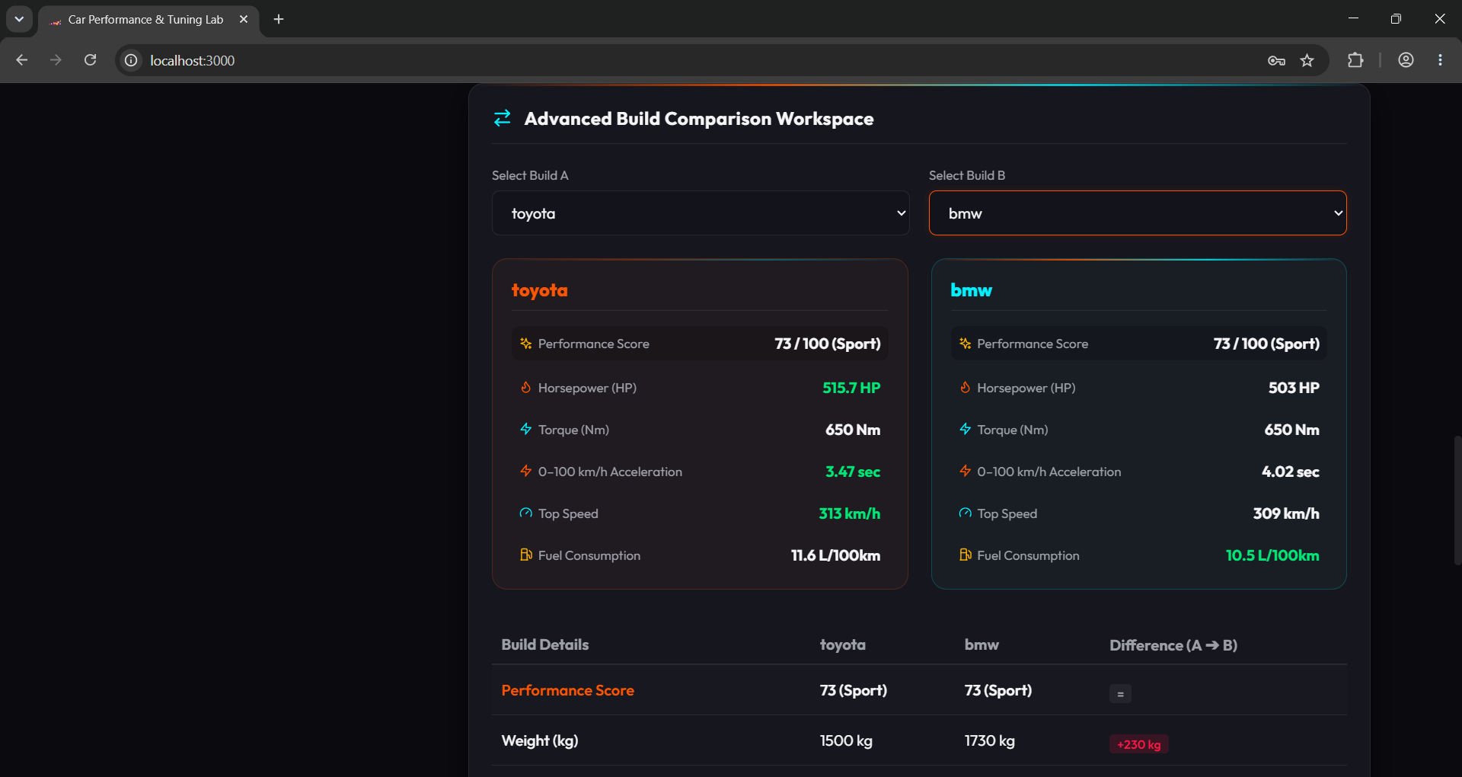
Figure 10.4 — Advanced Build Comparison Workspace showing the Toyota and BMW builds selected for side-by-side evaluation, including summary cards and the beginning of the detailed comparison table.

10.5 Detailed Metrics Comparison and Performance Index Chart
Continuing down the comparison workspace, the full metrics table displays Weight, Horsepower, Torque, 0-100 km/h Acceleration, Top Speed, and Fuel Consumption for both builds, with each row's Difference cell color-coded — red for a regression and green for an improvement relative to Build A. Beneath the table, a Performance Index Comparison chart (scaled from 0 to 100) presents a grouped bar chart across six normalized categories: Horsepower, Torque, Acceleration Rating, Speed Rating, Fuel Efficiency Rating, and Overall Score, giving users an at-a-glance visual summary of which build performs better in each dimension.
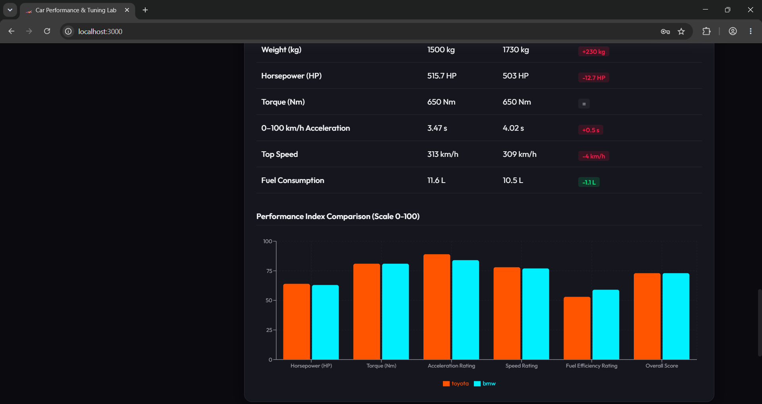
Figure 10.5 — Detailed build comparison table with color-coded differences, followed by the normalized Performance Index Comparison chart for the Toyota and BMW builds.

10.6 Exported PDF Performance Report
The PDF Export feature generates a formal, standalone report titled “Vehicle Performance & Tuning Analysis,” timestamped at the moment of generation. The report is organized into three clear sections: Technical Specifications (vehicle weight, drivetrain, and stock horsepower/torque), Applied Modifications (in this case, a Turbo Charger with its associated boost effects), and Performance Results & Differences, presented as a table listing the Stock Value, Modified Value, and computed Difference — including percentage change — for horsepower, torque, acceleration, top speed, and fuel consumption. This document allows users to archive or share their simulation results outside of the web application.
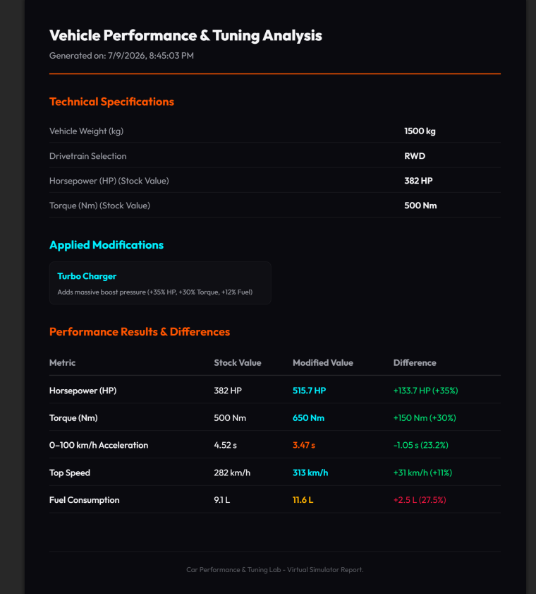
Figure 10.6 — Exported PDF report (“Vehicle Performance & Tuning Analysis”) summarizing technical specifications, applied modifications, and a full performance results table with computed differences.

11. Challenges and Solutions
- Synchronizing real-time state across multiple components: as vehicle specifications and modification selections changed frequently, keeping the Results Dashboard, charts, and comparison workspace all in sync proved challenging. This was resolved by centralizing the active configuration in a shared state/context layer so that every consuming component subscribed to a single source of truth, eliminating inconsistent or stale values between panels.
- Designing an accurate yet simple calculation model: balancing realism with simplicity in the calculation engine required research into general automotive performance relationships (power-to-weight ratio, drivetrain efficiency) without over-engineering a full physics simulation. The team addressed this by adopting percentage-based, additive modification effects combined with simplified but consistent formulas for acceleration and top speed, validated against known reference vehicles.
- Coordinating chart libraries with different rendering models: using both Recharts and Chart.js within the same interface introduced integration and styling inconsistencies. The team standardized a shared color palette (orange for stock values, cyan for modified values) and wrapped each chart in a consistent container component to unify their appearance across the dashboard.
- Implementing bilingual (Arabic/English) support: supporting Arabic introduced right-to-left (RTL) layout considerations that are not automatically handled by default CSS. This was solved by introducing a language context that toggles both translated text content and the document's text direction, ensuring labels, numbers, and charts remained legible and correctly aligned in both languages.
- Generating a well-formatted PDF from dynamic data: producing a polished PDF report using jsPDF required manually laying out text, tables, and section dividers, which is inherently more limited than HTML/CSS rendering. The team built reusable layout helper functions for headers, tables, and spacing to keep the generated report visually consistent with the in-app dashboard styling.
- Managing saved builds without a full database: since the project scope did not include a production-grade database, persisting saved builds reliably across sessions required careful use of the browser's Local Storage combined with defensive parsing to avoid corrupted or missing data breaking the comparison workspace.

12. Testing and Validation

12.1 Functional Testing
Each core feature — authentication, vehicle configuration, modification selection, real-time calculation, build saving, build comparison, and PDF export — was manually tested against a set of expected outcomes. Test cases verified that applying a known modification (for example, a Turbo Charger adding +35% horsepower, +30% torque, and +12% fuel consumption) produced the correct modified values, and that these values matched consistently between the on-screen dashboard and the exported PDF report.

12.2 UI Testing
The user interface was reviewed for visual consistency, correct color-coding of positive and negative changes (green for improvements, red for regressions), correct rendering of both charts, and correct behavior of interactive elements such as drivetrain selection buttons, dropdown menus, and modification checkboxes. Particular attention was paid to verifying that the Arabic language mode correctly mirrored the layout and translated all interface labels.

12.3 Responsive Testing
The application was tested across multiple viewport sizes, including desktop, tablet, and mobile breakpoints, to confirm that the Vehicle Specifications panel, Results Dashboard cards, and charts reflowed appropriately without loss of readability or functionality. Particular focus was given to ensuring that the comparison tables remained usable on narrower screens through appropriate scaling and spacing adjustments.

12.4 Feature Verification
A final verification pass cross-checked every feature listed in Section 7 against the live application to confirm complete implementation, including authentication, presets, real-time calculation, dashboard visualization, charts, save/compare builds, PDF export, language toggle, and dark mode, ensuring the delivered product matched the original project requirements.

13. Future Enhancements
- Integration with a persistent cloud database (e.g., MongoDB or PostgreSQL) to replace Local Storage for saved builds and simulation history, enabling cross-device access.
- Expansion of the vehicle presets database to include a significantly larger catalogue of makes and models across multiple regions and eras.
- A more sophisticated physics-based calculation model incorporating aerodynamic drag coefficients, gear ratios, and drivetrain loss more precisely.
- Social and community features, such as sharing builds publicly and allowing other users to comment or rate configurations.
- A mobile application built with React Native to extend the platform beyond the web browser.
- Enhanced accessibility support, including screen-reader optimization and additional language options beyond Arabic and English.
- Deeper integration of the Recommended Build Assistant using a rules-based or machine-learning-driven recommendation engine tailored to user goals such as track performance or fuel efficiency.

14. Conclusion
The Car Performance & Tuning Lab successfully demonstrates the practical application of the skills developed throughout the DEPI React Frontend Development Track, combining a polished, responsive, bilingual React and TypeScript interface with a Node.js and Express back end and a purpose-built calculation engine. The project delivers a complete, end-to-end user experience: from account creation and vehicle configuration, through real-time performance simulation and rich data visualization, to build comparison and professional PDF reporting.
Beyond meeting the functional requirements of the graduation project, the system reflects sound software engineering practices, including modular component design, type safety, clear separation between presentation and business logic, and thoughtful attention to usability and internationalization. The team is confident that this project represents a strong demonstration of front-end engineering capability and provides a solid foundation for the future enhancements outlined in Section 15.

